Algorithm Complexity Analysis

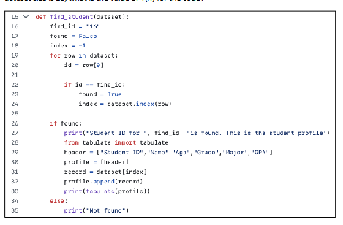

The given code is used for searching a student record using student id. The algorithm assigns the variable find_id the value 16. Subsequently, it creates two variables namely found and index which are used to track if the student record has been found and where it is stored in the dataset.
The core of the algorithm consists of a for loop.

for each row in dataset.

The loop iterates through one row of the dataset at a time. At each iteration, the algorithm fetches the student ID from the row and compares this ID to the target ID stored in find_id.

When id matches find_id.

In case of matching IDs, the algorithm updates the value of found as True and also stores the position of the row. The algorithm checks whether the student was found after the loop has completed its execution. The information in the student’s profile is shown if it exists. If not, the message “Not found' is printed. The algorithm uses a linear search approach as it sequentially searches through the dataset from the beginning to the end till the matching item is found. In the worst case, every record in the dataset may be checked by the algorithm before the student is found or before concluding that the student does not exist.

The temporal complexity of this algorithm is O(n).

As the size of our dataset (size of the loop) changes, the number of comparisons performed by the loop increases as well. The bigger dataset will require more time by the algorithm because more rows must be checked.

T(n) is the total number of operations done by the algorithm when the size of the data is n. The number of operations grows proportionally, as the algorithm may examine each record once.

Then the dataset size is 20.

"20"

In the worst case, the algorithm may need to perform 20 comparisons before it completes its search.
The algorithm implements a linear search as it goes through the dataset from start to end, checking each item one-by-one until it finds what it is looking for. In the worst case scenario, the algorithm may check all records in the database before finding the student or concluding that the student does not exist.

The time complexity of this algorithm is O(n).

As we change the size of our dataset (size of the loop), the number of comparisons performed by the loop also increases. The algorithm will spend more time on a larger dataset because there are more rows to check.

T(n) is defined as the complete functioning carried out by the algorithm when the size of the data is n. As the algorithm can examine each record once, the number of operations grows linearly.

